**Background and Scope**

Manitoba Agriculture and Resource Development has developed and recently launched the Land Identification Project that will be the single source platform for field data collection within the Province of Manitoba. This platform will be the centralized location where updates will be streamlined using the ArcGIS online platform.

There are two ways to collect data for this initiative either by:

**Option 1: Using the QR Code**

1. Open the camera on your mobile device
2. Position the camera to align with the QR Code below:

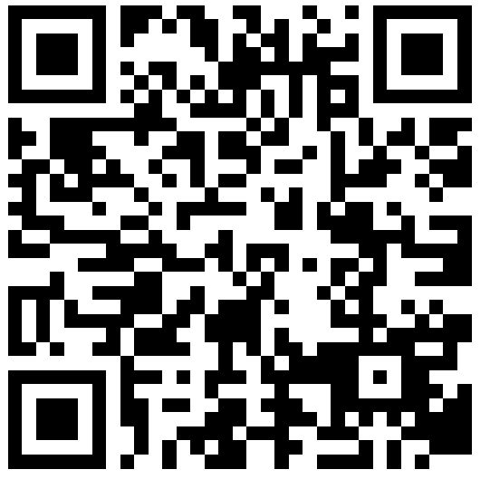

1. ****A prompt window will appear to Open in Survey 123

**Option 2: Downloading the Survey 123 App**

1. Click on **App Store** on iphone or tablet or **Google Play** on android.
2. For apple users, Type Survey 123 for ArcGIS in the search function (bottom right) and click on the **blue cloud** to the right.
3. User will need to enter their unique Apple ID and Password.
4. Once the app is download, open it by click on the **Survey 123**. 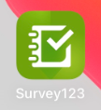
5. Click on **Continue without Signing in**



1. Within the My Survey 123 window, enter the following in the search:

<https://survey123.arcgis.com/share/e224d322052348fbbe1d91cc36ed1734>

1. Click on the Land Identification Tool



**Collecting Data:**

Fields that are identified with a red asterisk (*) is a required field and the survey will not be saved without those mandatory fields completed. For the location to be validated, a 10 metre accuracy is required. Users might need to stand in a different location or away from high obstructions to increase this accuracy.

1. Click the check mark on the bottom right to publish the point into the system

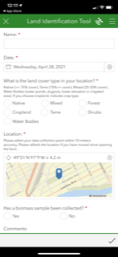

Any questions or concerns, please contact:

**Glenn Friesen**

Industry Development Specialist

Cell: 204-770-7266

Glenn.friesen@gov.mb.ca