February 26, 2026

Farm cash receipts represent agriculture’s top line revenue for the calendar year. For a complete review of financial results including farm expenses and total net farm income, visit manitoba.ca/agriculture/markets-and-statistics/financial-statistics in late May, when those data will be released.
Manitoba recorded farm cash receipts of $10.4 billion in 2025, up $580 million or 5.9 per cent compared with 2024. Canola, hogs, wheat, cattle and calves, soybeans, potatoes, milk, poultry and eggs, corn for grain, and oats make up the top ten sectors by cash receipts in 2025. Crops accounted for 57.6 per cent of total receipts, livestock for 38.3 per cent, and direct payments totaled 4.1 per cent of receipts.
Canola ranked first in farm cash receipts, while hogs moved into second place, replacing wheat. Canola produced $1.9 billion, representing 19 per cent of Manitoba’s total receipts. Hogs produced a record $1.8 billion (17 per cent), wheat brought in $1.5 billion (15 per cent), and cattle and calves surpassed one billion for the first time, reaching $1.2 billion (12 per cent). Soybeans also set a record, generating $883.4 million, or nine per cent of total farm cash receipts.
Total crop receipts increased marginally by 0.4 per cent in 2025 compared to 2024. Significant gains in soybeans, dry beans, corn for grains, and barley more than offset declines in wheat, canola, fresh potatoes, and oats. Soybeans receipts showed the largest increase at 68.2 per cent, followed by dry beans (27.8 per cent) and barley (19.2 per cent).
Manitoba’s livestock sectors generated record cash receipts of $4.0 billion in 2025, an increase of 15.7 per cent from 2024. The hog sector, which accounted for 45 per cent of all livestock receipts, generated $1.8 billion, up 14.4 per cent, due to higher prices and increased marketings. Cattle and calf receipts rose 27.2 per cent to a record $1.2 billion, driven by a 32 per cent increase in prices.
Supply-managed commodities generated $787 million in 2025, up five per cent from 2024, and represented 20 per cent of total livestock cash receipts. Milk sales reached $395 million (up five per cent), poultry contributed $226.5 million (down 1.1 per cent), and egg receipts totalled $191 million (up 11.4 per cent).
Sheep and lamb receipts increased 26.3 per cent to $17.1 million, while honey receipts declined 6.6 per cent to $38.8 million.
Program payments totalled $426.1 million in 2025, up four per cent from 2024. Crop insurance payments were $175.3 million (down 18 per cent), private hail insurance totalled $56.7 million (up 19 per cent), AgriInvest payments reached $38.4 million (up eight per cent), and AgriStability payments came in at $125.3 million (up 46 per cent). Direct payments represented 4.1 per cent of total farm cash receipts in 2025.

Across Canada, farm cash receipts increased 3.4 per cent in 2025 to a record $101.4 billion. Manitoba’s share of national farm cash receipts remained steady at 10.2 per cent. All provinces except Saskatchewan recorded increases in farm cash receipts in 2025.

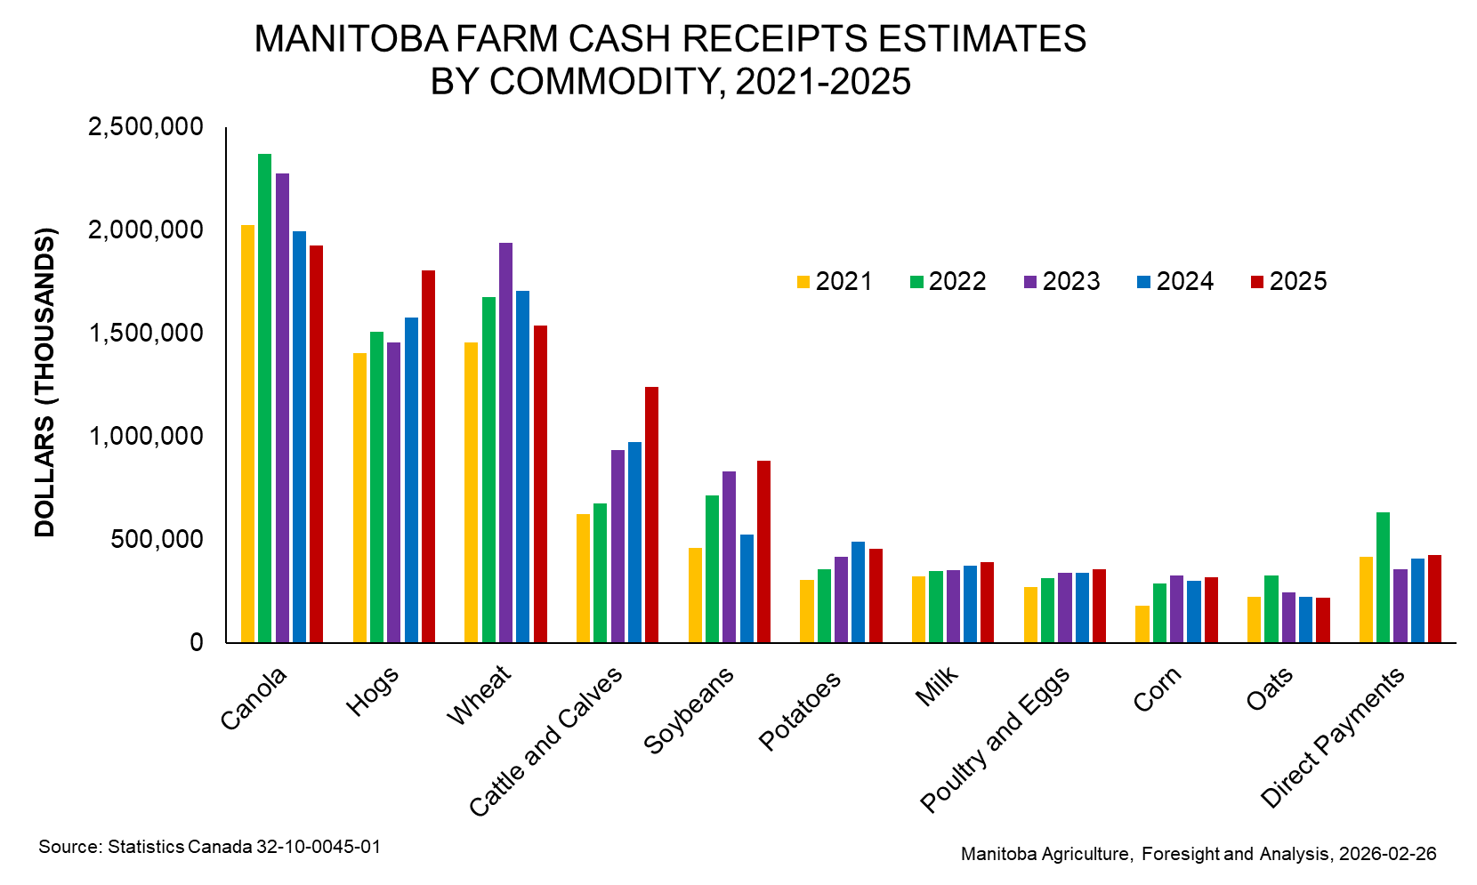

Contact us
- www.manitoba.ca/agriculture/markets-and-statistics/
- Email us at industryintelligence@gov.mb.ca
- Follow us on X @MBGovAg

