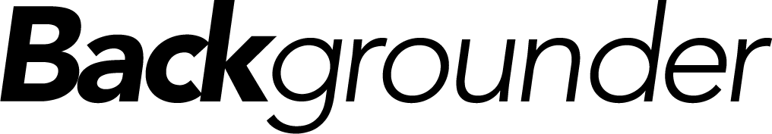

••••••••••••••••••••••••••••••••••••••••••••••••••••••••••••••

MINING ADVISORY COUNCIL

Representatives
• Chief Donovan Fontaine (Sagkeeng First Nation), co-chair;
• Chief Ron Evans (Norway House Cree Nation), co-chair;
• Chief Phillip Buck (Mosakahiken Cree Nation);
• Chief Clarence Easter (Chemawawin Cree Nation);
• Chief Jerry Primrose (Nichichawayasihk Cree Nation);
• Chief Andrew Colomb (Marcel Colomb Cree Nation);
• Chief Gilbert Andrews (Gods Lake Narrows);
• Chief Michael Constant (Opaskwayak Cree Nation);
• Grand Chief Irvin Sinclair of Keewatin Tribal Council;
• Lovro Paulic (vice-president, operations, Vale Manitoba; chair, Mining Association of Manitoba);
• Tom Goodman (retired from Hudbay Minerals);
• Tom Lewis (vice-president, exploration, Wildcat Exploration);
• Brad Lantz (vice-president, Manitoba Business Unit, Hudbay Minerals); and
• Dale Ginn (executive vice-president, San Gold).

Responsibilities
The Mining Advisory Council will bring leadership from Manitoba First Nations and the mineral industry to increase First Nation participation in the province’s mineral resources sector and build the mining industry in Manitoba. The group will:
• make recommendations in resource revenue and benefits sharing,
• promote and increase business opportunities,
• participate in training and employment and joint ventures, and
• consult as a matter of good governance and Section 35 Crown-Aboriginal consultations.

