Localized Improvement Fund for Tomorrow (LIFT)
Small Grants Fund (SGF)
Application Form
Fall 2014 Intake

To qualify for the grant, the project should:
- Reflect the program objective of community building/connecting and demonstrate community support. Examples of demonstrate community support include: letters of support from community organizations, 10 adult residents’ signatures, 5 potential program participants.
- Be sponsored by local groups (not individuals) such as a school parent council, daycare centre, or resident association. The group does not need to be incorporated.
- Not be used for capital improvements to private property unless the property has been made available, free of charge, for community use and the improvements relate to the proposed community use.

Examples of eligible projects: block parties, community celebrations, neighbourhood cleanups, community gardens, art projects, cultural events and other such projects that support community connecting.
Eligible costs may include: materials and supplies, equipment or other rentals and staffing costs.
Costs NOT ELIGIBLE include: stipends or honorariums for participation or contribution to on-going wages for staffing.

Instructions:
Prior to completing the application, please review program requirements. Fill out the application form attached and send complete signed application to Neighbourhoods Alive!
By mail: 400 – 352 Donald Avenue, Winnipeg, MB, R3B 2H8
By fax: 204-948-1065
By email: nalive@gov.mb.ca
Please include: “LIFT Small Grants Fund Application” on the front cover. If you have questions, please call 204-945-3379 or email nalive@gov.mb.ca

Intake Deadline: October 1, 2014

Name of Applicant (e.g. organization/club affiliation or community group):
_____________________________________________________________________________

Provide a brief description of the organization/club/group:

Mailing Address (include postal code):

Please check off the LIFT area your project will be in: (See attached Maps: Appendix A)

□ Alpine-Lavallee □ Elwick

□ Osborne-Mayfair □ South Pembina

□ Weston

(If you have questions about the boundaries of your LIFT locality please contact Neighbourhoods Alive! at 204-945-3379)

Main Project Contact Person
(Note: The Main Project Contact Person cannot benefit financially from this grant)

Name:_______________________________________________________________________

Phone:___________________________Email:_______________________________________

2nd Contact Person (if applicable)

Name:_______________________________________________________________________

Phone:___________________________Email:_______________________________________

PROJECT DESCRIPTION

- Small Grant Amount Requested $________________________ (Must be under $5,000)

- Project Title: ___________________________________________________________

- Brief description of the project:

- How will this project build community or connect community members in your LIFT locality?

5. How will the project be accomplished and by whom? Identify participants, committees, groups, etc., who will be involved in carrying out your project.

6. Does this project take place on property other than the applicant’s?

_____ No
_____ YES

If yes, is written permission or approval attached?

_____ Yes (written approval is attached with this application form)
_____ No (written approval will be sent in at a later date)

7. How have you demonstrated the support of local residents for this project?

8. Anticipated project start date: _____________

Anticipated project end date (Project must be completed by March 31, 2015): __________

9. Please include a detailed budget for the project and at least two quotes for any work to be done by contractors.

(If you have questions about preparing a budget please contact Neighbourhoods Alive! at 204-945-3379)

_______________________________ _____________________________
Applicant Signature Date
APPENDIX A: MAPS
Weston Osborne-Mayfair

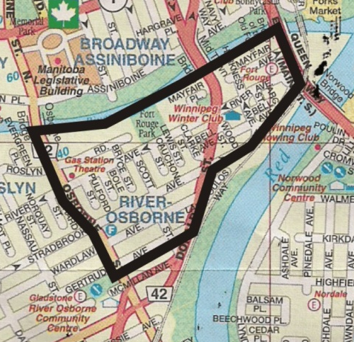
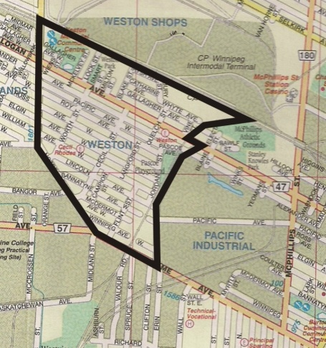

Elwick Alpine-Lavallee
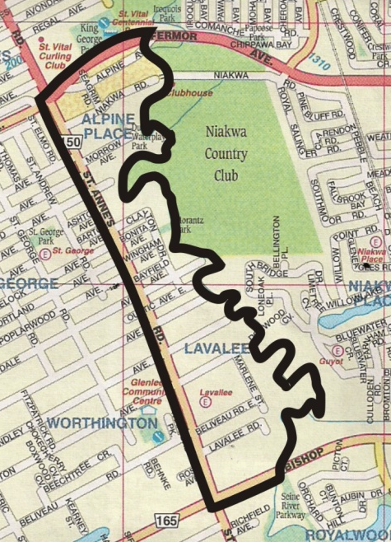
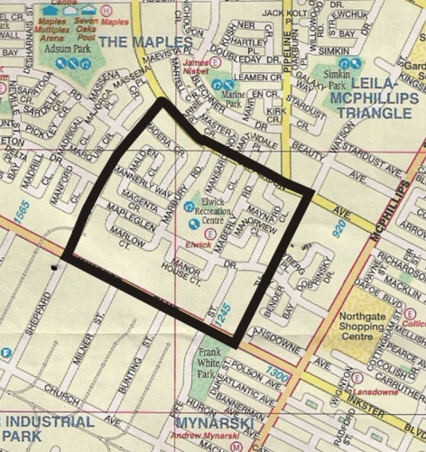

South Pembina

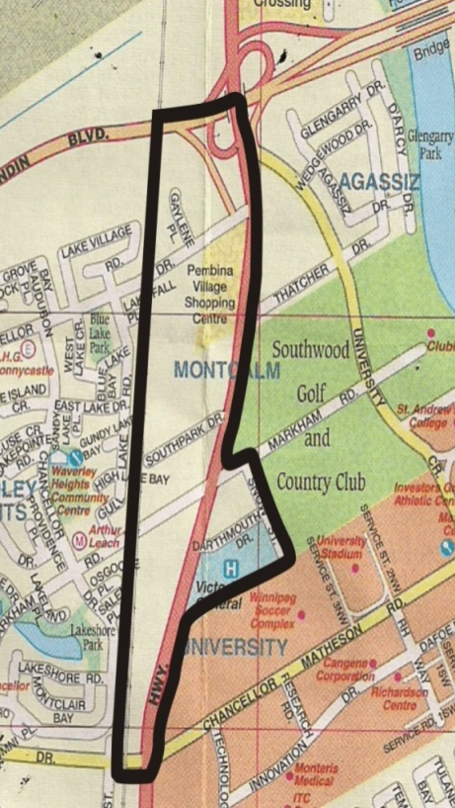
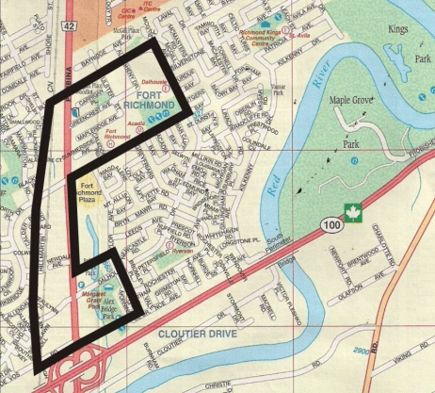

(If you have questions about the boundaries of your LIFT locality please contact Neighbourhoods Alive! at 204-945-3379)

