Manitoba 
Industry, Economic Development Petroleum 360-1395 Ellice Avenue
and Mines Winnipeg MB R3G 3P2
CANADA

Phone: (204) 945-6577
Fax: (204) 945-0586

October 13, 2005

INFORMATIONAL NOTICE 05-02

Withdrawal of Crown Oil and Gas Rights from Disposition

Effective immediately, the Department of Industry, Economic Development and Mines will not be accepting applications under Subsection 2(2) of the Crown Disposition Regulation for the disposition of Crown oil and gas rights by public sale in the area currently under potash disposition for exploration and/or development (“potash disposition area”) outlined in Schedule A. This Notice does not affect the rights of holders of existing dispositions of Crown oil and gas rights in the potash disposition area.

A potash lease in the Russell area has been held by the Manitoba Potash Corporate since 1987. The Department is in the process of issuing a potash exploration permit in the St. Lazare area to Agrium Inc. The term of the potash exploration permit is five years and may be extended in accordance with the provisions of the Potash Exploration Permit Regulation under The Mines and Minerals Act.

Oil and gas operations have the potential to adversely impact the integrity of potash deposits. In order to mitigate this risk, the Department has decided not to dispose of Crown oil and gas rights in the potash disposition area while holders of potash dispositions undertake activities to evaluate potash deposits. The Department hopes the orderly development of the province’s subsurface resources will maximize the value of these resources for the future benefit of all Manitobans.

The Department’s decision not to dispose of oil and gas rights in the potash disposition area will be reviewed at the end of the term of the potash exploration permit or earlier in the event of surrender of all or a portion of the permit area or termination of the potash lease or exploration permit.

If you have any questions in respect of the withdrawal of Crown oil and gas rights from disposition, please contact Carol D. Martiniuk, P.Geo., Manager, Administration & Geology at (204) 945-6570.

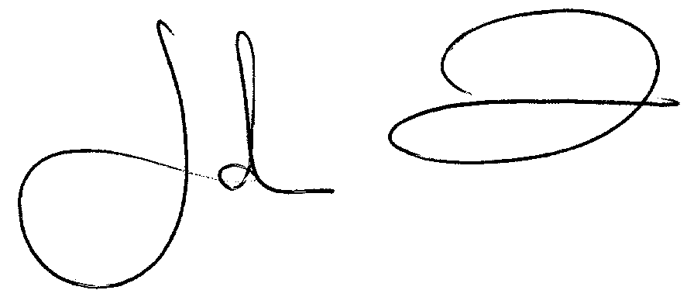
John N. Fox, P.Eng.
Director

