How to Zip, Encrypt and E-mail a File
Step 1: Right Click on the file that you want to encrypt using WinZip.
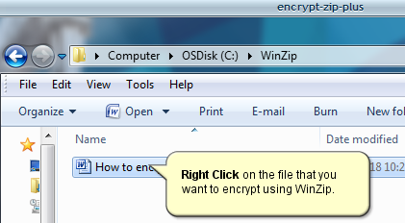
Step 2: Hover your mouse over WinZip, and then on Zip and E-Mail Plus, and click on Zip and E-Mail Plus
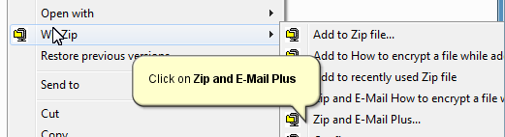
Step 3: Click “Encrypt Zip file” Check Box and then Click OK.
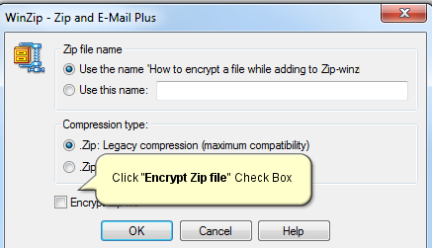
Note: You can change the file name here by checking “Use this name” and entering in a file name.
Compression type: You can use either type of compression; however, you may need to use Zip vs. Zipx for recipients who use older versions of Winzip.
Step 4: Type in a password. The password must be at least 8 characters long, and should include both numbers and letters. Click the OK button to continue.
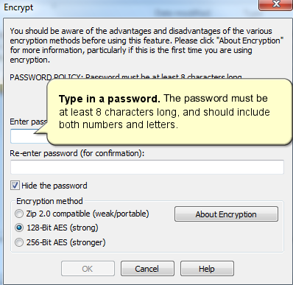
Note: You can uncheck the “Hide the password” Check box to view your password as you are typing it.
Leave the default selection for the Encryption method as “128-Bit AES” (strong).
Step 5: Email the file to the recipient. A dialogue box will open and insert the encrypted file into a new email message. Email the file to the recipient and inform them of the password preferably by phone.
