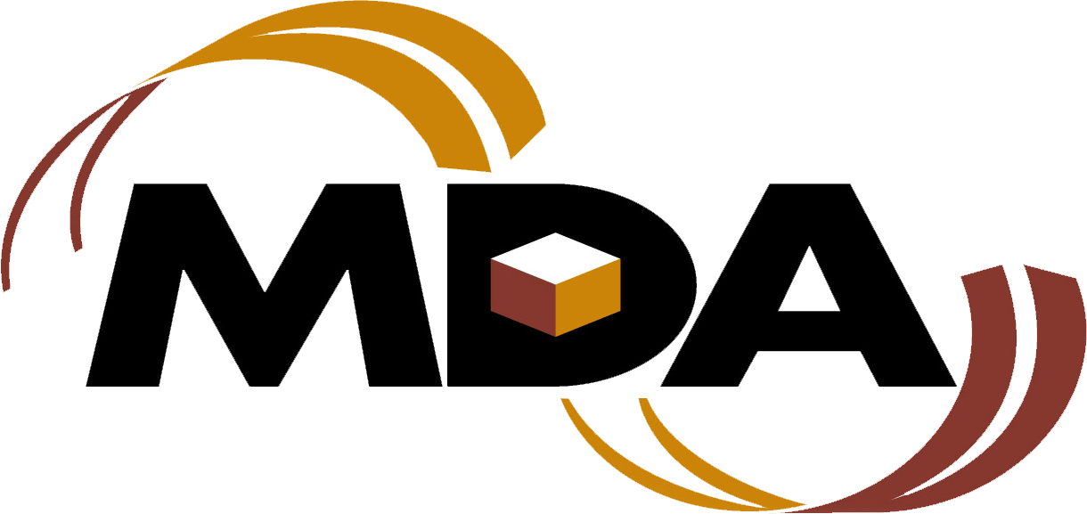

Rapid Testing Kits -

Client Account Number Application Form
To access MDA Rapid Testing products please complete the following application form and email to mdaaccounting@gov.mb.ca.

Client Information
Client Name/Title:
Organization/Department:
Address: Room/Floor:
City: Province: Postal Code:
Phone: Fax:
Email Address:
Tax Status: PST Exempt GST Exempt

Funding Information
Non-Government: Private
Government Level: Federal Provincial Municipal
Funding Information: Publicly Funded Non-Profit
Funding Organization: _______________________________________________
Funding Organization Contact Name: ____________________________________
Funding Organization Telephone Number: ________________________________

MDA Product and Services
MDA Products – Rapid Test Kits

Materials Distribution Agency
7-1715 St. James Street Winnipeg MB R3H 1H3
mdaaccounting@gov.mb.ca

