Comprehensive Study Scoping Document

for
Lower Mattagami Hydroelectric Complex Redevelopment
CEAR Reference Number: 07-03-26302

Prepared pursuant to Subsection 21(1) of the
Canadian Environmental Assessment Act (CEAA)

by

Fisheries and Oceans Canada

March 2007

table of contents

1. Introduction 3
1.1. Background 3
1.2. Purpose of the Document 4

2. overview of the development proposal 4
2.1. Components of the development proposal 4
2.1.1. The Generating Stations 4
2.1.2. Operating Pattern 5
2.1.3. Spillway and Reservoir Operations 6
2.1.4. Transmission Lines 6
2.1.5. Access Roads and Bridge 7
2.1.6. Other 7

3. Environmental Assessment Requirements 10
3.1. Responsible Authority 10
3.2. Expert Federal Authorities 10
3.3. Federal EA Type 11
3.4. Federal Environmental Assessment Coordinator 11

4. PROPOSED SCOPE OF THE FEDERAL ENVIRONMENTAL ASSESSMENT 11
4.1. Proposed Scope of Project 11
4.2. Proposed Scope of Assessment 12
4.2.1. Factors to be considered in the Environmental Assessment 12
4.2.2. Proposed Scope of the Factors to be Considered 13
4.2.2.1. Environmental Components to be Examined 13
4.2.2.2. Spatial and Temporal Boundaries 14

5. PUBLIC CONSULTATION 14
5.1. Invitation for Comments & Further Opportunities for
Public Participation 14
5.2. Submission of Comments 15
5.3. Participant Funding 15
5.4. Canadian Environmental Assessment Registry 15

Introduction

Ontario Power Generation (OPG) is proposing to redevelop the Lower Mattagami Hydroelectric Complex, located approximately 70 km northeast of Kapuskasing. Little Long, Harmon and Kipling generating stations will be expanded with the addition of a turbine/generator and the Smoky Falls site will be redeveloped to accommodate a new generating station.

Background

The development proposal was originally initiated in the late 1980s. A provincial Environmental Assessment (EA) entitled “Hydroelectric Generating Station Extensions, Mattagami River: Environmental Assessment” was prepared and the development received approval under the Ontario Environmental Assessment Act in 1994 with a number of terms and conditions. This approval was subsequently extended by the Ontario Minister of Environment and is valid until December 15, 2010.

A federal screening of the development proposal was conducted under the Environmental Assessment and Review Process Guidelines Order (EARPGO) in 1995. However, the development proposal did not proceed and no federal government regulatory approval or authorization was ever sought for it.

In July, 2006, OPG provided to Fisheries and Oceans Canada (DFO) an updated description of the development proposal. This proposal differs from the one originally reviewed under the EARPGO. More specifically, the components related to the Smoky Falls generating station were altered from those reviewed under the previous assessment.

As a result, DFO has determined that it may exercise regulatory decision-making authorities in regard to some components of the development proposal in order for them to proceed. For this reason, pursuant to paragraphs 5(1)(d) of the Canadian Environmental Assessment Act (CEAA), DFO is required to ensure that a federal environmental assessment of these components is conducted prior to taking its decision.

This Comprehensive Study Scoping Document was prepared by Fisheries and Oceans Canada, pursuant to subsection 21(1) of the Canadian Environmental Assessment Act (CEAA).

Purpose of the Document

The purpose of this document is to provide information to the public on the proposed Redevelopment of the Lower Mattagami Hydroelectric Complex and on the federal environmental assessment process under CEAA, and to seek public comment on the assessment to be conducted in relation to the development proposal. Consistent with the requirements of subsection 21(1) of the CEAA, this report, with respect to the development proposal for the Lower Mattagami Hydroelectric Complex is intended to be used to consult with the public on the following items:

- the proposed scope of the project for the purpose of a federal environmental assessment;
- the factors proposed to be considered in the assessment and the proposed scope of those factors; and
- the ability of the comprehensive study to address issues relating to the project subject to the environmental assessment.

overview of the development proposal

The four generating stations (Little Long, Smoky Falls, Harmon and Kipling) are located on the Mattagami River between 60 and 100 km north of Kapuskasing (Figure 1.1). The stations are accessible by road from Kapuskasing and Smooth Rock Falls. The Smoky Falls generating station was put in service in 1931, the Little Long station in 1963, the Harmon station in 1965 and the Kipling station in 1966.

With the redevelopment of the Lower Mattagami Hydroelectric Complex, OPG wishes to provide increased overall generating capacity as well as promote more efficient operation and use of water through the complex.

Components of the development proposal

This section outlines the main components of the development proposal submitted by OPG.

The Generating Stations

The current development proposal consists of the following:

Little Long

Addition of a third turbine/generator unit to increase total station capacity from 136 MW to 204 MW.

Harmon

Addition of a third turbine/generator unit to increase total station capacity from 140 MW to 240 MW.

Kipling

Addition of a third turbine/generator unit to increase total station capacity from 156 MW to 240 MW.

The original design and construction of the Little Long, Harmon and Kipling stations included provision for future unit extensions of up to two units although only one unit is under consideration for the development proposal. As such, only minor modifications to the actual structures are required.

Smoky Falls

The Smoky Falls site will be redeveloped (see layout C, page 9). This will include the construction of a new generating station with an operating capacity of 271 MW (264 MW generator capacity) immediately adjacent to the existing plant facility and the construction of new approach channel, intake and tailrace. The Smoky Falls site redevelopment will also include the decommissioning of the existing 52 MW plant facility and the rehabilitation of the water retaining structures (East Earth-Fill Dam, West Concrete Gravity Dam and spillway structure).

Operating Regime

Current

Smoky Falls generating station was constructed prior to the Little Long, Harmon and Kipling and served a different purpose. Smoky Falls generating station is considered a "baseload" station and operates effectively 24 hours per day at a total flow capacity of 188 m³/s. The three other stations (Little Long, Harmon and Kipling) are considered "peaking" stations and operate approximately 5 hours per day at a flow capacity which ranges from 485-542 m³/s. As a result, their combined ability to utilize available river flow for energy production is not optimal.

Proposed

The proposed design of the Lower Mattagami Hydroelectric Complex would allow the utilization of the same flow rates at each of the generating stations. The complex would operate on a weekly schedule versus the current daily schedule. Because all the generating stations would have similar discharge capacities, they would be operated in step, with each station discharging the same quantity of water and passing it to the next station downstream. During high flow periods, the stations would be capable of running 7 days per week and 5 days per week during low flow periods. Under the terms and conditions of the provincial environmental assessment approval OPG is required to provide flow downstream of Kipling GS during the weekend shutdowns.

Spillway and Reservoir Operations

Under normal conditions, the outflow from the Little Long reservoir will be through the generating stations. During any outage of a generating station, the spillway at the station experiencing the outage will be operated to pass the desired flow to the other stations. During periods of high water flows (e.g., spring runoff) when the reservoir is at its maximum limit, the spillway at Adam Creek will be operated in addition to the Little Long generating station to pass the full Mattagami River flow. The duration and magnitude of the spill down Adam Creek will be less than is currently experienced since the unit capacity of the hydroelectric complex will have been increased allowing greater flows to be passed through the complex.

Transmission Lines

The proposed transmission facilities include the following:

- construct a double-circuit 230-kV line along the existing 115-kV corridor from the new Smoky Falls GS to the existing double-circuit 230-kV line (approximately 4 km)
- add additional single-circuit 230-kV line from Kipling GS to Harmon GS on existing towers (approximately 4.5 km)
- add additional single-circuit 230-kV span line from Harmon GS to the last (closest) tower of the existing double-circuit 230-kV line (approximately 200 m)
- add additional single-circuit 230-kV span line from Little Long GS to the last (closest) tower of the existing double-circuit 230-kV line (approximately 200 m).

Access Roads and Bridge

The existing 75-km long road from Kapuskasing to Little Long GS will be upgraded where necessary to provide safe travel and to accommodate the heavy traffic anticipated during construction.

Access to the intake and the generating station at Smoky Falls will be provided by a new road crossing the existing tailrace to the generating station via a permanent new bridge crossing the existing Smoky Falls tailrace. The bridge will have a span of approximately 45 m.

Other

- At Smoky Falls, a new switchyard will be required to provide the take-off point for the transmission line.
- A construction camp is proposed near the Smoky Falls GS site at the location of the former Smoky Falls colony. The camp site will provide accommodation for as many as 500 single status workers in prefabricated, trailer type units.
- Construction at the Smoky Falls site will require borrow and impervious material as well as fine aggregates that will be extracted from two borrow pits.
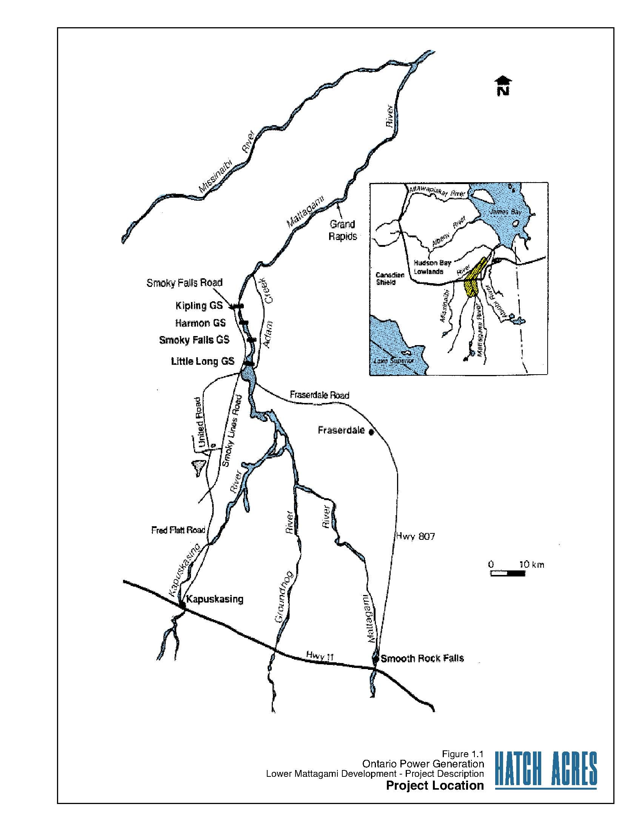

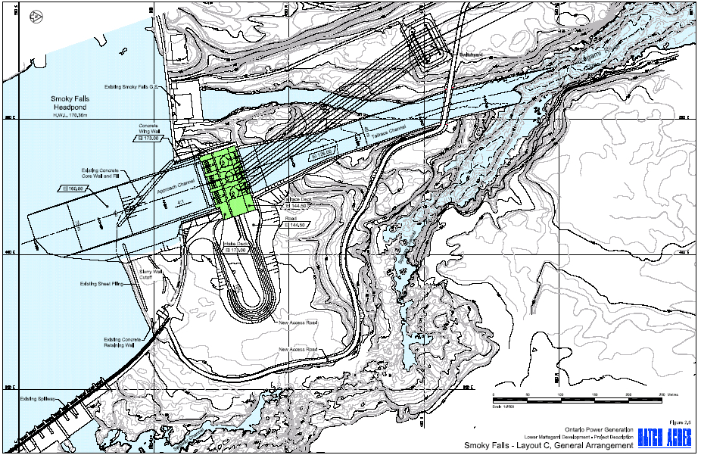

Environmental Assessment Requirements

Responsible Authority

Fisheries and Oceans Canada

DFO’s role as a responsible authority under the CEAA arises from the anticipated requirement for a Fisheries Act subsection 35(2) Authorization for the Harmful Alteration, Disruption, or Destruction of fish habitat and a Fisheries Act section 32 approval for the Destruction of Fish by Means Other Than Fishing. Based on the information provided to date, these will be associated with the following works and activities in relation to the proposed development: the decommissioning of the existing Smoky Falls generating station; the construction of a new generating station at the Smoky Falls site; the construction of an approach channel at the Smoky Falls site; the construction of a new tailrace at the Smoky Falls site which includes the alteration of the existing tailrace; the removal of an existing pond at the Smoky Falls site; and the proposed changes to the operating regime of the hydroelectric complex. These anticipated regulatory approvals under the Fisheries Act are Law List Regulations triggers under paragraph 5(1)(d) of the CEAA

In recognition that much of the Lower Mattagami Development has been previously assessed under the Environmental Assessment Review Process Guideline Order (EARPGO), DFO will make use of information from the initial assessment and report, to whatever extent is appropriate, for the purposes of complying with the current provisions of CEAA.

Expert Federal Authorities

Federal authorities are those federal departments identified through the Regulations Respecting the Coordination by the Federal Authorities of Environmental Assessment Procedures and Requirements process as having existing knowledge/expertise. Federal authorities are consulted during the scoping process; during review of environmental assessment materials submitted by the proponent and any other material relating to the comprehensive study; and prior to submission of the Comprehensive (CSR) to the Minister of the Environment. Environment Canada, Health Canada, Transport Canada and Natural Resources Canada have been identified as federal authorities for this assessment.

Federal EA Type

DFO has determined that a component included in the proposed scope of project of the proposed Redevelopment of the Lower Mattagami Hydroelectric Complex is subject to a comprehensive study under CEAA pursuant to Part II, paragraph 4(b) of the Comprehensive Study List Regulations, which reads:

4. The proposed construction, decommissioning or abandonment of
(b) a hydroelectric generating station with a production capacity of 200 MW or more.

The construction of a new 271 MW capacity generating station at Smoky Falls exceeds the threshold listed under paragraph 4(b) of the Comprehensive Study List Regulations.

Federal Environmental Assessment Coordinator

The Canadian Environmental Assessment Agency (Agency) is the federal environmental assessment coordinator (FEAC) for the proposed development proposal and is responsible for coordinating the review activities of the responsible authorities and expert federal authorities in accordance with section 12 of the CEAA. To the extent applicable, the FEAC will facilitate the coordination of the current federal EA process with the requirements of the provincial terms and conditions.

PROPOSED SCOPE OF THE FEDERAL ENVIRONMENTAL ASSESSMENT

Proposed Scope of Project

Pursuant to section 15 of the CEAA, DFO as the responsible authority, proposes that the scope of the project for the purposes of the federal environmental assessment include the physical works and activities associated with the construction, operation and maintenance and decommissioning (where applicable) of certain components of the development proposal. DFO has determined, based on the anticipated Fisheries Act, sections 35(2) and 32 triggers under the Law list regulations of the CEAA, that the scope of project will include the following components:

- The construction, operation and maintenance of a new generating station at the Smoky Falls site.
- The construction, operation and maintenance of an approach channel and its associated works or activities at the Smoky Falls site.
- The construction, operation and maintenance of a new tailrace and its associated works or undertakings at the Smoky Falls site, which includes the alteration of a portion of the existing tailrace.
- The removal of an existing pond at the Smoky Falls site.
- The construction, operation and maintenance of a bridge and its associated works or activities over the existing Smoky Falls tailrace.
- The decommissioning of the existing Smoky Falls generating station and its associated works or activities.
- The rehabilitation of water retaining structures at the Smoky Falls Site and its associated works or activities.
- The change to the operating regime of the hydroelectric complex.

Proposed Scope of Assessment

The scope of assessment also defines the factors proposed to be considered in the environmental assessment and the proposed scope of those factors. During a comprehensive study, the RA is required to consider the factors specified in section 16 of CEAA, taking into consideration the definitions of the environment, environmental effect and project.

As defined under CEAA, “environmental effect” means, in respect of a project:

a) any change that the project may cause in the environment, including any change it may cause to a listed wildlife species, its critical habitat or the residences of individuals of that species, as those terms are defined in subsection 2(1) of the Species at Risk Act
b) any effect of any change referred to in paragraph (a) on
i) health and socio-economic conditions
ii) physical and cultural heritage
iii) the current use of lands and resources for traditional purposes by aboriginal persons, or
iv) any structure, site or thing that is of historical, archaeological, paleontological or architectural significance, or
- any change to the project that may be caused by the environment
whether any such change or effect occurs within or outside Canada;

Factors to be considered in the Environmental Assessment

Under section 16 of CEAA, the following factors must be considered in a comprehensive study:
- the environmental effects of the project, including the environmental effects of malfunctions or accidents that may occur in connection with the project and any cumulative environmental effects that are likely to result from the project in combination with other projects or activities that have been or will be carried out;
- the significance of the environmental effects referred to above;
- comments from the public that are received in accordance with this Act and the regulations;
- measures that are technically and economically feasible and that would mitigate any significant adverse environmental effects of the project;
- the purpose of the project;
- alternative means of carrying out the project that are technically and economically feasible and the environmental effects of any such alternative means;
- the need for, and the requirements of, any follow-up program in respect of the project; and
- the capacity of renewable resources that are likely to be significantly affected by the project to meet the needs of the present and those of the future.

Proposed Scope of the Factors to be Considered

The following provides information on the proposed scope of the factors to be considered by the Responsible Authority in the environmental assessment.

Environmental Components to be Examined

Further to subsections 16(1) and (2) of the CEAA, the CSR will consider the environmental components listed below and document any issues and concerns that may be identified through any regulatory, stakeholder and/or public consultation.

- Climate, meteorology and air quality
- Geology and groundwater quality and quantity
- Surface water flows, quantity and quality
- Terrestrial and fluvial landforms
- Fish and fish habitat
- Terrestrial wildlife and wildlife habitat
- Wetlands
- Human Health
- Heritage resources
- Land and resource use including current use of lands and resources for traditional purposes by aboriginal persons
- Navigation

The environment assessment will consider potential effects the project may have on the environment with a focus on Valued Ecosystem Components (VECs). VECs of interest in the area of the development proposal are to be chosen through consultation with the federal authorities, provincial agencies and potentially affected communities, incorporating traditional knowledge and land use.

Spatial and Temporal Boundaries

Temporal and spatial boundaries will be determined for each VEC, early in the assessment. Temporal boundaries refer to the determination of the time period during which a VEC could be impacted by the project (e.g., during the construction phase). Spatial boundaries refer to the determination of the geographical area within which a VEC could be impacted by the project (e.g. footprint of a tailrace). The study area for the environmental assessment should encompass the area within which all of the VECs could be impacted.

PUBLIC CONSULTATION

Invitation for Comments & Further Opportunities for Public Participation

The public is invited to provide comments at this scoping stage of the environmental assessment of the project on the following areas:

- the proposed scope of the project;
- the factors proposed to be considered in the assessment;
- the proposed scope of those factors; and
- the ability of the comprehensive study to address issues relating to the project.

After consideration of the comments received, the RA will be submitting a report summarizing the above and providing a recommendation to the federal Minister of the Environment on whether the environmental assessment should continue by means of a comprehensive study or be referred to a mediator or a review panel.

If the Minister of the Environment determines that a comprehensive study will be conducted for the project, the public will be provided with further opportunities to participate.

The public will also have opportunities to participate in the assessment should the project be referred to a mediator or a review panel.

Submission of Comments

The public is invited to provide its views at this scoping stage of the environmental assessment.

Persons wishing to submit comments may do so in writing to Fisheries and Oceans Canada, by close of business (minimum 30 days period) DATE TO BE DETERMINED.

Comments may be sent to:

Rich Rudolph
Fisheries and Oceans Canada
Telephone: 705-522-5907
Fax: 705-522-6421
E-mail: rudolphr@dfo-mpo.gc.ca

Please be as detailed as possible and clearly reference the LOWER MATTAGAMI HYDROELECTRIC REDEVELOPMENT project and the CEAR Registry File number 07-03-26302 on your submission.

PLEASE NOTE: All documents and/or responses received regarding this project are considered public and will become part of the Project file of the CEAR.

Participant Funding

The Government of Canada, through the Canadian Environmental Assessment Agency, will provide participant funding to assist groups and individuals to take part in the environmental assessment, whether it proceeds by means of a comprehensive study or is referred to a mediator or review panel. Information on the program, including the Participant Funding Program Guide, the application form and the contribution agreement are available on the Agency’s Web site at http://www.ceaaacee.gc.ca/

Canadian Environmental Assessment Registry

Pursuant to the CEAA, section 55, the Canadian Environmental Assessment Registry (CEAR) has been established to provide notice of the environmental assessment, and facilitate public access to records related to the environmental assessment. The CEAR consists of a project file and an internet site. The internet component of the CEAR can be accessed at the following address: http://www.ceaa.gc.ca/050/Viewer_e.cfm?SrchPg=1&CEAR_ID=26302

Anyone wishing to obtain copies, or view records, on the CEAR project file should contact:

DFO - CEA Registry Office -Central & Arctic Region - Ontario Area
P.O. Box 5050
867 LAKESHORE ROAD
Burlington ON L7R 4A6
Telephone: (905) 336-4508
Email: CEAROntario@dfo-mpo.gc.ca

If you have general questions in relation to the CEAA, you can access the CEA Agency website at: http://www.ceaa-acee.gc.ca

