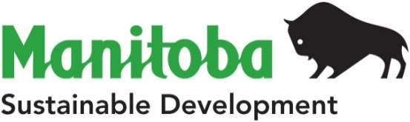
Sustainable and Green Initiatives
Box 38, 200 Saulteaux Crescent
Winnipeg, Manitoba R3J 3W3
T 204-945-2041 F 204-945-4552
www.manitoba.ca

Waste reduction and Recycling Support (WRARS) Program
AUTHORIZED Contact Update form

Contact Information
Organization Name:
Authorized Contact Name: | Title:
Address:
Town/City: | Postal Code:
Phone: | Fax:
Email Address:

Landfill(s):
Waste Transfer Station(s):
Recycling Program

Information collected using this form is required for the administration of the WRARS Program. Manitoba Sustainable Development may publish the information collected. If you have any questions about the use of the collected information, please contact Jennifer Lusk in Winnipeg by phone at 204-945-2041 or by email at Jennifer.Lusk@gov.mb.ca.

Collection and use of personal information is protected by the privacy provisions of The Freedom of Information and Protection of Privacy Act (FIPPA). If you have any questions about the collection and use of personal information under FIPPA, please contact the Access and Privacy Officer in Winnipeg by phone at 204-945-4170 or by email at cws-fippa@gov.mb.ca.

The authorized contact understands the requirements for the WRARS Program and agrees to cooperate with all WRARS policies and procedures.
Authorized Contact Signature Date

Send Completed Form to:
WRARS Program
Manitoba Sustainable Development
Box 38, 200 Saulteaux Crescent
Winnipeg, MB R3J 3W3
Fax: 204-945-4552
Email: Jennifer.Lusk@gov.mb.ca

For Manitoba Sustainable Development Use Only
Date Processed: | Approved By:

