First Jobs Fund Funding Application Guide
TRAINING AND EMPLOYMENT SERVICES
ECONOMIC DEVELOPMENT, INVESTMENT, TRADE AND NATURAL RESOURCES

Table of Contents

First Jobs Fund – Application Guide 3
Troubleshooting Adobe 4
Section 1: Company/Organization Information 4
Section 2A: Company/Organization Profile 4
Section 2B: Truth and Reconciliation 5
Section 3A: Project Description 8
Title and Dates 8
Project Overview 8
What is the key issue the organization is addressing? 8
Project Objectives 8
Project Activities 9
Section 3B: Project Evaluation 11
Section 4: Project Budget 11
Appendix A 13
Activity/Service Definitions 13
Appendix B 16
Participant Information Fields 16
Appendix C 18
Eligible and ineligible expenses 18
Appendix D 20
Required documentation 20
Appendix E 21
Reporting Requirements 21

First Jobs Fund – Application Guide
This guide has been prepared to assist service providers in completing the First Jobs Fund application for funding provided by Training and Employment Services (TES) – Economic Development, Investment, Trade and Natural Resources.
The First Jobs Fund (FJF) is available for projects, up to $225,000, providing employment activities for NEW EMPLOYEES (youth between the ages of 15-29).
Eligible applicants are registered non-profit youth serving, or non-government organizations (NGO) (NGO definition).
Note: Private businesses may partner with a non-profit/NGO for the work experience portion of the project but are NOT eligible to apply independently.
To be considered for funding, organizations must include BOTH of the following activities as part of their application:
- Job readiness activities that deliver employability skills, mentorship, job coaching and life skills to youth participants, and;
- Work experience initiatives that provide a minimum of seven (7) hours of employment per week and a minimum of 150 hours of employment to each participant.

Additionally, applicants must show how the project meets the First Jobs Fund program areas, including:
- Programming targeted at youth facing multiple barriers to employment, that is inclusive and accessible to Indigenous and BIPOC participants.
- Paid work experience opportunities
- Truth and Reconciliation activities
- Skills/experience for in demand jobs and key economic sectors
- Offering services in rural and/or northern communities

PLEASE NOTE:
- Funding is not guaranteed and is contingent upon eligibility and availability. Projects will be approved based on First Job Fund priority areas.
- The application must be submitted on behalf of the Board of Directors/organization by an individual who has legal signing authority and/or is authorized to act on behalf of the Board/organization.
- You will be contacted by a government staff member to set up a phone or in- person appointment to review your application and discuss next steps.
- If an application is approved, the organization will be required to sign an agreement with the Government of Manitoba which stipulates how the funds are to be spent and the reporting requirements.
- Applications are considered part of the agreement and therefore you may be asked to make revisions.

Troubleshooting Adobe
If you have any issues opening the application and/or inputting information, check the following:
- Ensure you have the latest version of Adobe downloaded
- Make sure you have Enable All Features chosen (upper right-hand side)
When your application is complete (including the Project Budget)
  - Save it as: Organization Name and Project Title
  - Email to: youthpartnerships@gov.mb.ca
Ensure that you complete all data fields in each section of the application. Failure to do so will cause a delay in processing the request.

Section 1: Company/Organization Information
  - Enter the organization name, Business Number, operating name, mailing address, telephone, fax and email address.
  - Provide the name, job title and direct telephone number of the individual who should be contacted by Manitoba to provide additional information and answer questions about the application.
  - Provide the name, telephone, fax, and email address of the person with legal financial signing authority. ONLY complete if different from the previous contact information.

Section 2A: Company/Organization Profile
- Provide a general description of the organization. This should include the following:
  - Description of the organization – who does the organization serve (population/age/demographic/area in province/etc.)?
  - What products/services does it produce?
  - Mission/vision statement
  - Community partners – does the organization work with partners on program development and/or delivery
- Indicate if the organization has Worker’s Compensation and/or 3rd Party Liability Insurance.
  - Organizations must have 3rd Party Liability and/or Worker’s Compensation to be under contract with the province.
- Provide the number of years the organization has been in business.
- Indicate full time and part time employees attached to the project. Definitions:
  - Full time employees: regularly works a minimum of 30 hours per week.
  - Part time employees: regularly works less than 30 hours per week.
- Indicate whether or not employees are unionized and whether or not the organization has union concurrence for the project, and the name of the union (or association).

Section 2B: Truth and Reconciliation
The Government of Manitoba supports reconciliation through ongoing work and relationships with Indigenous colleagues, clients and communities and by addressing related Truth and Reconciliation Calls to Action:
  - #7: We call upon the federal government to develop with Aboriginal groups a joint strategy to eliminate educational and employment gaps between Aboriginal and non-Aboriginal Canadians.
  - #92: We call upon the corporate sector in Canada to adopt the United Nations Declaration on the Rights of Indigenous Peoples as a reconciliation framework and to apply its principles, norms, and standards to corporate policy and core operational activities involving Indigenous peoples and their lands and resources. This would include, but not be limited to, the following:
    - Commit to meaningful consultation, building respectful relationships, and obtaining the free, prior, and informed consent of Indigenous peoples before proceeding with economic development projects.
    - Ensure that Aboriginal peoples have equitable access to jobs, training, and education opportunities in the corporate sector, and that Aboriginal communities gain long-term sustainable benefits from economic development projects.
    - Provide education for management and staff on the history of Aboriginal peoples, including the history and legacy of residential schools, the United Nations Declaration on the Rights of Indigenous Peoples, Treaties and Aboriginal rights, Indigenous law, and Aboriginal-Crown relations. This will require skills-based training in intercultural competency, conflict resolution, human rights, and anti-racism.
This question is to recognize reconciliation activities and to support organizations’ contributions towards programming is respectful of the cultural and historical experiences of Indigenous people, and advances reconciliation through support of inclusive workplace cultures and access to jobs.

Consider the following questions in your response:
  - What partnerships have or are expected to occur between your organization and Indigenous communities?
  - To what extent were or will Indigenous communities involved in designing, implementing and/or delivering your project?
  - How does the programming include recognition or Indigenous culture? If it’s not included, how could it be?
  - Does your organization provide education for staff and/or clients on the history of Indigenous people including the history and legacy of residential schools?
  - Does your organization ensure that Indigenous people are represented in your program(s)? If yes, how so? If no, what could be done to increase inclusion?

Frequently Asked Questions

Questions | Answers
If the activities do not support reconciliation efforts, will my project still be considered for funding? | Yes. All projects will be reviewed and considered for funding. This question is intended to gather expertise and experiences from organizations regarding reconciliation efforts.
The project our organization is proposing works primarily with non-Indigenous clients, and does not have any specific reconciliation related elements built in. Is this OK? | Yes. There is not an expectation for all projects to deliver a pre-determined activity related to reconciliation. Your organization is asked to reflect on what activities, services, and/or information could be included in your program to support reconciliation. Department staff will work with your organization to support building reconciliation activities into your project, if that support is needed. The nature of the activities will vary depending on organizational and client needs.
Our organization is Indigenous- led, working primarily with Indigenous clients, do I need to answer this? | Organizations are invited to provide a response but not required. The experience and knowledge, that Indigenous-led organizations bring, provides a valuable perspective and is welcomed and appreciated.
Our organization would like to learn more about what the Government of Manitoba is doing to support reconciliation, where can I find this information? | https://www.gov.mb.ca/inr/reconciliation- strategy/index.html
Our organization has been very successful working with Indigenous clients, and we do not have specific reconciliation activities embedded into programming. Will my project have to change? | The department is pleased to partner with organizations who deliver strong outcomes through supportive programming. The updated question in the application is an opportunity to learn more about each organization’s reconciliation efforts, and this includes organizations who are not engaged in specific reconciliation activities. Your organization is invited to reflect on how your program could be  updated to ensure all clients are supported in the context of advancing reconciliation.
Is this work being done in consultation with the Indigenous community? | Yes. As this work continues, the department remains committed to working in partnership with the Indigenous community and Indigenous-led organizations to ensure efforts are meeting the needs of the community.
Our organization works with clients from diverse backgrounds. All clients are provided with information on the history of Indigenous people including the history and legacy of residential schools, by way of an information package that includes information and website, other resources to access for further learning. Is this sufficient for the question? | There is not a ‘right or wrong’ answer for this question. You are invited to share what you have been doing, and to think about how this information sharing could grow to ensure all clients have an opportunity to engage with the information in a safe space.

Section 3A: Project Description
This section request information on the need or issue your organization is addressing, the actions to be taken to solve the problem, the results expected to achieve, and how the organization will measure those results.

Title and Dates
  - Enter the project title: e.g., Digital Training for Employment
  - Enter the dates when the project will start and end

Project Overview
Provide a high level description of the project and how the organization will ensure project success. The overview should include answers to the following (but not limited to):
- Who is the target audience and how will they be recruited into the project? What are the barriers to employment and how will the project address this?
- Where will the paid work experience opportunities take place? Who are the employers that have expressed an interest in this?
- Outline how the Truth and Reconciliation activities will be incorporated in the overall project delivery. How will these activities move Truth and Reconciliation forward?
- What are the expected skills/experience that will be gained? Will these skills/experience assist in filling gaps for in demand jobs and key economic sectors?
- Is the project expected to be offered in rural and/or northern communities? Please outline the project delivery areas.

What is the key issue the organization is addressing?
  - First Jobs Funds projects must address youth unemployment
  - For example: Digital Training for Employment key issues may be:
    - Lack of youth represented within the Digital Media Industry
    - Youth will be filling a skill gap within the industry in Manitoba, which is expected to have 55% vacancy rate within 5 years.

Project Objectives
What will the project do? What is the project expected to achieve?
  - Describe what the project is expected to achieve by the end date.
  - Outline of how the organization will achieve project objectives and goals.
  - Are the objectives measurable, achievable and realistic?

Example:
Goal: Youth Employment
Objectives:
- Increase the number of youth successfully maintaining their first job experience.
- Address the skills gaps within the digital media industry.
Outcomes:
- Youth are returning to further education to pursue digital media as a career option.
- Youth are choosing digital media for employment.
- The digital media industry has an expanded talent pool of future employees.
Has the organization delivered similar programs?
  - Choose Yes or No
    - If yes – provide an example(s) of any similar programs delivered by the organization. Briefly outline the outcomes/results of this initiative(s).

Project Activities
Step 1: Answer the following question on the application:
- Are there participants for this project?
  - All First Job Fund projects must choose Yes.
A Training/Activity Plan chart (see below) will appear
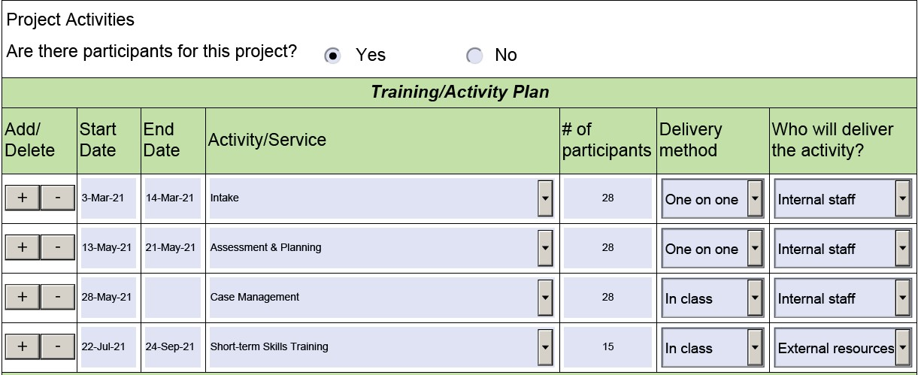

Step 2: Complete the Training/Activity Plan by adding each service your organization will be delivering
  - See Appendix A for Activity/Service drop down menu explanations and definitions
  - To add additional activities, select plus sign (+)

Each First Job Fund applicant must choose an option that best describes the project.
Step 3: On the drop down menu, select the following option:
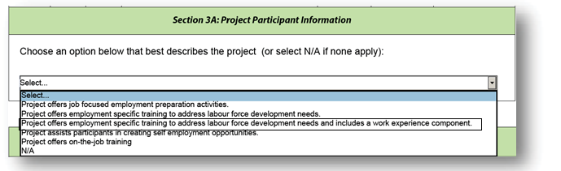
- Project offers employment specific training to address labour force development needs and includes a work experience component.

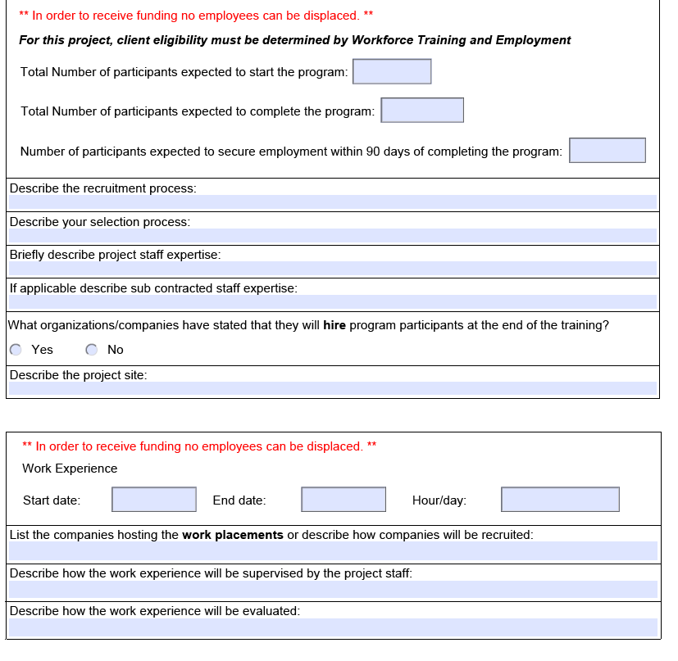
Once you choose the appropriate option for the First Jobs Fund project, please complete the additional fields that have been generated as follows:

See Appendix B for additional information on how to complete this section of the application.

Section 3B: Project Evaluation
Project Evaluation
What are the outcomes and results that will occur from the project? Examples could include:
  - How many clients does the organization expect to successfully complete the program?
  - How many clients will drop out due to life circumstances?
  - How will the organization collect client information?
    - Telephone interviews; one-on-one sessions; survey
  - Outline how the organization will determine if the project is successful
  - What benefits are expected from the project?
  - Outline how the organization will report these outcomes, how often and when the organization will submit the final report.
  - See Appendix I for reporting requirements

Section 4: Project Budget
NOTE: The project budget is completed using an Excel spreadsheet available on the First Jobs Fund program website. This is a separate document from the application form and must be submitted with the application.
- Indicate if your organization is presently receiving money from TES and details of the funding agreement.
- Indicate if your organization has applied for funding from any other source for this project. This information is used to avoid duplication of funding for the same project.
- Indicate if there are any other organizations involved with the project and resources they will provide in-kind (free of charge).
  - The in-kind amount can be included in the Source of Funding table
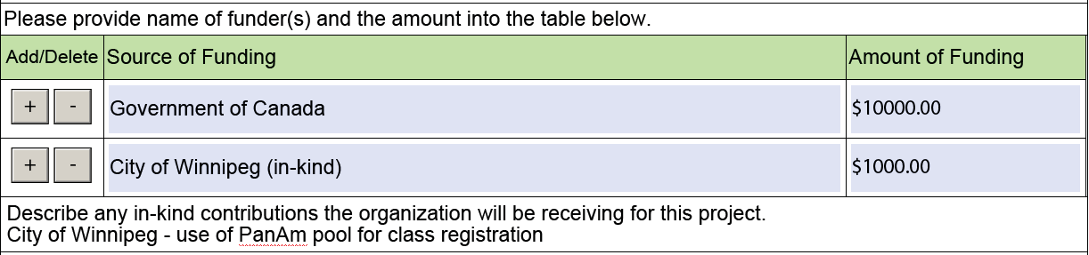

- Indicate how this project will be financially monitored and what checks and balances are in place to ensure that the project stays on budget.

Important to note:
- Training and Employment Services reimburses on actual expenditures only.
- Funding must not be due to offset reductions in funding received from other sources or to subsidize other operations or programs delivered by the organization.
- Project activities must not commence until an agreement is signed. Any costs incurred prior to both parties signing the agreement will not be reimbursed.
See Appendix C for a list of eligible and ineligible expenses.

Appendix A

Activity/Service Definitions

Term | Definition
Intake | Review of the service offerings, to a client, provided by the organization. Each project participant is required to complete an intake and consent form
Case Management | This service should remain open for the entire duration of the client’s intervention.  Individualized case management and counselling supports provided to a client as they progress in their action/service plan to achieve their employment goals.  - On-going career development.  - Supporting development of a career plan (includes goal setting, planning and motivation).  - Working with the client to navigate services.  - Providing on-going supports and referrals.  - Monitoring progress and providing case coordination with other staff and services.  - Exploring, identification and clarifying values, interests, education, experience, strengths and abilities in relation to career and employment goals.  - Exploration of career paths, jobs, sector work environment, culture, occupational and training requirements related to career and employment goals, including trades and apprenticeship.  - Support, mentoring (mentor) and coaching (coach) during the job search process.  - Frequent monitoring and follow-up.  - Referral to other community resources and supports.  - Assisting the client in the implementation of the agreed upon activities through co-ordination of services in support of the career goal.  - Assisting the client in identifying suitable employment opportunities and establishing necessary employer contacts.  13. Closure - to determine the appropriate timing for case closure and to refer to other more appropriate services, if required.
Job Search Assistance | Client or workshop-based support to help client clarify their employment goals and expectations, assess their skills and interests, prepare resumes and build interview skills so they can conduct a successful job search. These include:  - Cover Letter  - Interview Skills  - Labour Market Information and Assistance  - Resume Writing
Job Development Matching & Placement | WORK EXPEREINCE COMPONENT: Assists clients who are facing labour market access barriers to find and connect with appropriate employment opportunities that are reflective of their skills and strengths as well as employer needs. The purpose is to help clients connect with a permanent job opportunity by providing the employer with employer incentives.
Short Term Skills Training  NOTE: this includes Truth and Reconciliation (TRC) activities. | This could include the following:  - Computer software or project management short course  - First Aid, CPR, WHIMIS etc. that provide a certificate upon completion  - Life skills training such as time management, critical thinking, self-assessment, etc.  - TRC activities including workshops to raise the awareness of the history and creation of the residential school system, its ongoing legacy, and how it has shaped the country we live in today.
Foundation Skills/Literacy Training | Training to improve literacy skills for purpose of accessing education and training, improving employment potential, and/or addressing personal literacy needs.
Foundation Skills/Language | Training to improve English or French language training.
Foundation Skills/Prior Learning and Essential Skills | The assessment and training in essential skills. Essential Skills include reading, writing, digital technology, document use, oral communications, thinking skills, numeracy, working with others, continuous learning.
Employability Skills Workshops | Employability skills workshops are intensive sessions designed to assist clients to better prepare for the world of work. Typically, a client will attend a series of workshops dependent on their individual need. There are 4 unique categories available:  - Essential Skills  - Pre-employment preparation  - Career Decision Making  - Life Skills

Appendix B

Participant Information Fields
Project offers employment-specific training to address labour force development needs and includes a work experience component.
Number of participants expected to start the program
- The number of participants that the organization expects to participate in the project.
Total number of participants expected to complete the program.
- The number of participants expected to complete the program.
Number of participants expected to secure employment within 90 days of completing the program.
- The number of participants expected to secure employment because of the training offered. Projects are evaluated on the number of clients employed within 90 days of project completion.
Describe the recruitment process.
- How will the organization recruit participants into the project? Examples could include: newspaper ads, ads on social media, community outreach, community organizations, etc.
Describe the selection process.
- How will the organization determine whether or not a candidate will be a good fit with the program?
  - Interviews?
  - Will there be any testing?
  - Will past experience in this field be taken into consideration?
Describe project staff expertise.
- What knowledge/skills will the project staff bring? What past experiences(s) do they have in this area? Do they have education that is relevant to the project?
Describe sub contracted staff expertise (if applicable).
- What knowledge/skills does the contracted staff bring to the project? What past experiences(s) do they have in this area? Do they have education that is relevant to the project?

What organizations or companies have stated that they will hire the participants at the end of the training?
- Indicate which organizations/companies have expressed an interest in this training and would be willing to hire a participant afterwards
  - Projects must show that there is a labour market demand in order for this training to take place
Describe the project site.
- Give a brief description of the project site, the area it is located, is it on a bus route, disability accessible, access to computers, hours of operation, etc.
Work Experience
- Enter the work experience start and end dates
- Enter how many hours per day the participants will spend at the work experience
List the companies hosting the work placements or describe how companies will be recruited.
- What companies/organizations have indicated that they would be willing to host a work experience?
Describe how the work experience will be supervised by the project staff.
- Over the phone, on site monitoring.
Describe how the work experience will be evaluated.
- Show up every day, attitude, form for host organizations to complete etc.

Appendix C

Eligible and ineligible expenses

ELIGIBLE EXPENSES (not a complete list)
Staff
  - Salaries
  - MERCs (Mandatory Employer Related Costs)
  - Insurance (Workers Compensation and/or Third Party Liability)
Operating/Overhead
  - Board Insurance
  - Rent
  - Telephone and Internet
  - Photocopying
  - Office Supplies
  - Travel
  - Hospitality Costs
    - Preapproved one time allocation of up to $250 for Grand Opening
    - Preapproved allocation of $20 per month for discretionary hospitality funding per project
Client Assistance
  - Criminal Record checks
  - Vaccinations
Participant Costs
  - Printing of certificates for graduation
  - Participant Wages
Persons with Disabilities
  - Training Costs
  - Personal Supports
Capital Costs (must supply 3 quotes)
  - Computer
  - Furniture
Training Costs Subcontracted

INELIGIBLE EXPENSES
  - Employee Benefits including
    - Company pension plans
    - Dental/medical plans
    - Life insurance
  - Parking
  - Nutritional costs
  - Graduation ceremony costs
  - Administration Fees – with the exception of universities and colleges
  - GST on Service Provider Services

Appendix D

Required documentation
Organizations that have been approved, will be asked to show TES the following documents (if applicable) at the first activity monitor:
  - Conflict of Interest policy
  - Nepotism policy
  - Confidentiality of Participant Information Policy
  - Electronic Media Disposal Policy
  - Participant Policies
  - Personnel policies for absenteeism, suspension, termination, statutory holidays
  - Project staff resumes
  - Project staff position descriptions
  - Organization’s Personnel Policies
  - Letter/Memo from Board stating organizations wish to submit this application
  - Articles (ex Articles of Incorporation)
  - Board Bylaws
  - List of Board of Directors and Executive
  - List of Board Delegated Signing Officers
  - Current Annual Report
  - Proof of Workers Compensation or Third Party Insurance
  - Proof of Commercial General Liability
  - Board Liability
  - Written Union concurrence

Appendix E

Reporting Requirements
Manitoba is required to report on the results of any project to which it provides funding. Reporting on results provides information on what worked, what didn’t work and needs to be changed. This can allow a program to evolve and change to meet client needs on a proactive basis. These reports are a requirement of receiving support through the province and consist of both narrative and financial reporting. The following can be expected:

Progress Reports
Completed through Service Provider Reporting Solution (SPRS) and/or narrative, or a combination of both.
Progress reports allow project staff to identify if the project is on track to meet the following (but not limited to):
  - Target number of participants
  - Achievement of expected outcomes – are clients meeting expected outcomes?
  - Delivery of activities – will activities take place within the expected timeframe of the contract? Are there new activities that have been identified?
  - Are there project changes that need to occur
  - Project expenditures
Projects reporting through SPRS will have predetermined headings which organizations will report against. These headings are set up by government staff and reflect the contractual agreement.
Organizations work with their TES staff member to determine the frequency of the reports.
Final Report
Completed through Service Provider Reporting Solution (SPRS) and/or narrative, or a combination of both. The final report outlines the following:
  - The activities that were delivered
  - The total number of clients served (the outputs)
  - The outcomes of the activities – (example: were the clients successful in completing the program? Did this close the labour market issue being addressed? Were clients successful in obtaining employment?)
The final report must be submitted to Manitoba within 90 days of the project completion date.

